A Practical activity Report submitted

For BUGGY PROJECT (UTA-011)

By

**Name of Student:- Pranav Pratap Singh**

**Roll Number:- 101610068**

**Submitted to : Mr Kunal Singh**



**ELECTRONICS AND COMMUNICATION ENGINEERING DEPARTMENT**

**THAPAR UNIVERSITY, PATIALA-147004, PUNJAB**

**INDIA**

**Experiment – 1(a)**

**Objective :** To design a schematic diagram of receiver circuit for gantries placed at different locations on the path to be followed by Buggy Robot.

**Software Used :** Eagle

**Components Used :**

|  |  |  |  |
| --- | --- | --- | --- |
| **Sr no** | **Name of components** | **Value** | **Specification** |
| **1.** | Resistors | 120k, 22k, 100k, 1k | Carbon resistor with 5% tolerance |
| **2.** | Capacitors | 0.1uF, 100nF | Electrolytic |
| **3.** | Diode |  | MBD701 |
| **4.** | IC |  | LM311D |

**Circuit diagram:**

**Schematic diagram:**

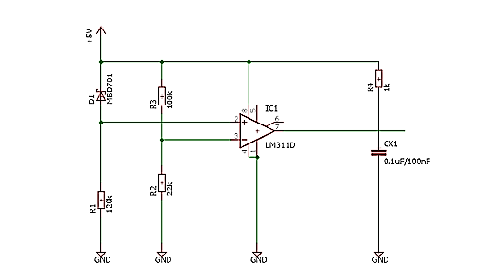

**Layout Design :**

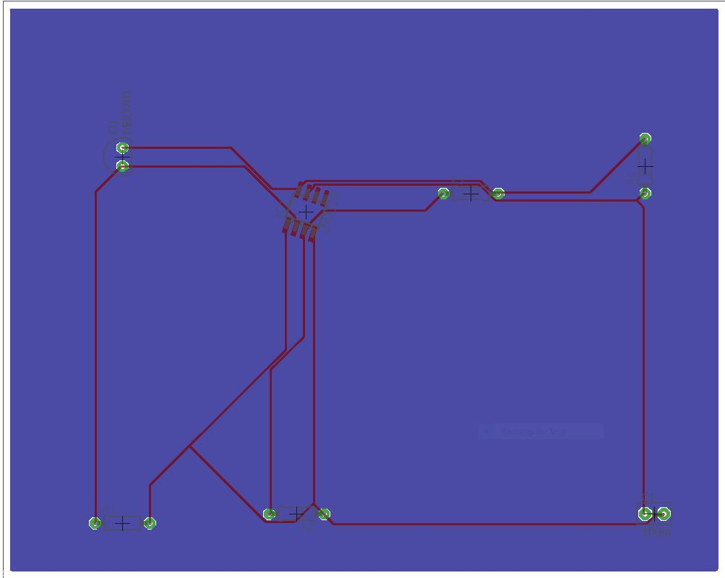

**Discussion :**

1. Resistors- A **resistor** is a [two-terminal](https://en.wikipedia.org/wiki/Terminal_(electronics)) [electrical component](https://en.wikipedia.org/wiki/Electronic_component) that implements [electrical resistance](https://en.wikipedia.org/wiki/Electrical_resistance) as a circuit element. In electronic circuits, resistors are used to reduce current flow, adjust signal levels, to divide voltages. High-power resistors that can dissipate many [watts](https://en.wikipedia.org/wiki/Watt) of electrical power as heat may be used as part of motor controls, in power distribution systems.
2. Capacitors- A **capacitor** is a two-terminal electrical component that stores electrical [energy](https://en.wikipedia.org/wiki/Energy) in an electric field. The effect of a capacitor is known as [capacitance](https://en.wikipedia.org/wiki/Capacitance). The capacitor is a component which has the ability or “capacity” to store energy in the form of an electrical charge producing a potential difference across its plates, much like a small rechargeable battery.
3. MBD701- This is also known as Schottky Barrier Diode. It is designed primarily for high-efficiency Ultra high frequency detector applications. They are supplied in an inexpensive plastic package for low-cost , high-volume consumer and industrial requirements.
4. LM311D - This is single high-speed voltage comparators. These devices are designed to operate from a wide range of power-supply voltages, including ±15-V supplies for operational amplifiers and 5-V supplies for logic systems. The output levels are compatible with most TTL and MOS circuits.